Ray’s rentals

Final Submission

**Faran Azadi, Aamer Atique, Yusof Bandar, Naim Ahmed and Pritam Sangani**

Table of Contents

1.0 Executive Summary 3

2.0 Management Reports 4

3.0 Use Case Diagram 5

3.1 Use Case Specifications 5

3.1.1 Update Customers Record 5

3.1.2 Update Maintenance Record 6

3.1.3 Update Bike Record 7

3.1.4 Order Parts 8

3.1.5 Update Rental Record 9

4.0 RDAs 11

4.1 Maintenance and Dealer Record RDA 11

4.2 Rental and Bike Record RDA 11

4.3 Merged RDA 11

5.0 ERDs 12

5.1 Top - Down ERD 12

5.2 Bottom – Up ERD of Merged RDA 13

5.3 Finalised Group ERD 14

5.4 Commentary of ERD Creation 15

6.0 Amended Group ERD 16

7.0 Data Dictionaries 17

7.1 Rental Record 17

7.2 Reservation Record 17

7.3 Dealer Record 17

7.4 Fault Report Record 17

7.5 Customers Record 18

7.6 Enquiry Record 18

7.7 Sold Bikes Record 18

7.8 Bike Record 18

7.9 Class / Size Record 19

7.10 Maintenance Record 19

7.11 Bike Parts Record 19

7.12 Supplied Parts Record 19

7.13 Ordered Parts Record 20

7.14 Manufacturer Record 20

8.0 Reflection on what has been learnt doing SQL 21

8.1 Aamer Atique 21

8.2 Faran Azadi 21

8.3 Naim Ahmed 21

8.4 Yusof Bandar 22

8.5 Pritam Sangani 22

9.0 Conclusion 23

9.1 Aamer Atique 23

9.2 Faran Azadi 23

9.3 Naim Ahmed 23

9.4 Yusof Bandar 23

9.5 Pritam Sangani 23

10.0 Appendices 24

10.1 References 24

10.2 Appendix A: Log Book 24

10.3 Appendix B: Presentation Slides 24

# 1.0 Executive Summary

Aamer will do this

# 2.0 Management Reports

# 3.0 Use Case Diagram

# 3.1 Use Case Specifications

## 3.1.1 Update Customers Record

|  |
| --- |
| **Use Case: Update Customers Record** |
| **Owner**: Manager |
| **Pre-Conditions** |
| 1. No existing Customer Record |
| **Post-Conditions** |
| 1. Customer added to Customer Record |
| **Primary Path** |
| 1. New customer requests an account 2. Customer details acquired 3. Customer details are updated to Customer Record |
| **Alternate Path** |
| 1. Customer details are wrong 2. Customer details are not entered into Customers Record |
| **Notes** |
| Pritam Sangani |

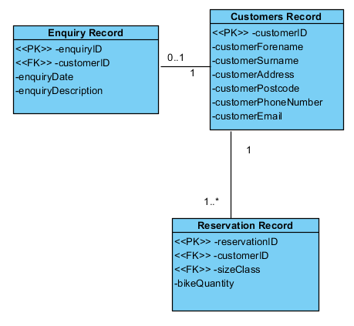

## 3.1.2 Update Maintenance Record

|  |
| --- |
| **Use Case: Update Maintenance Record** |
| Owner: Manager |
| **Pre-Conditions** |
| 1. Customer returns bike reporting a fault. 2. Manager services the bike finding a fault. |
| **Post-Conditions** |
| 1. After the bike fault(s) have been fixed by the technicians, the maintenance record is updated and the bike is ready to be hired out again. |
| **Primary Path** |
| 1. Customer returns bike reporting a fault with the bike. 2. The staff report back the fault to the technicians and make the bike unavailable. 3. The bike is then added to the maintenance record adding the fault with the bike. 4. The maintenance record is updated again once the bike has been fixed. |
| **Alternate Path** |
| 1. No fault is found, by the customer or the manger, with the bike. |
| **Notes** |
| Yusof Bandar |

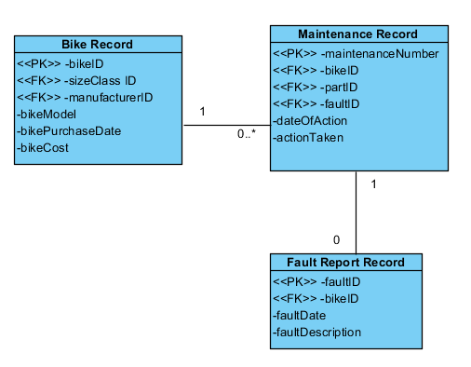

## 3.1.3 Update Bike Record

|  |
| --- |
| **Use Case: Update Bike Record** |
| Owner: Manager |
| **Pre-Conditions** |
| 1. Existing bike record |
| **Post-Conditions** |
| 1. Bike record updated with correct information |
| **Primary Path** |
| 1. New bike(s) is bought by manager from supplier or manufacturer using Manufacturer Record 2. Bike(s) bought is received 3. Bike(s) details are entered into the Bike Record |
| **Alternate Path** |
| 1. Bike bought is never received 2. Cancel order 3. Don’t update Bike Record with new bike details |
| **Notes** |
| Naim Ahmed |

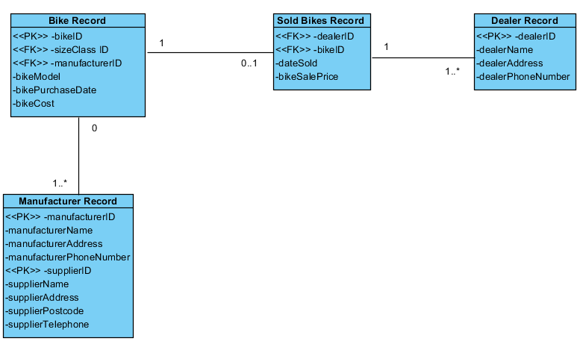

## 3.1.4 Order Parts

|  |
| --- |
| **Use Case: Order Parts** |
| Owner: Parts Manager |
| **Pre-Conditions** |
| 1. Existing Part ID 2. Existing Supplier ID |
| **Post-Conditions** |
| 1. Delivery notice 2. Delivery invoice |
| **Primary Path** |
| 1. Parts Manager does a stock check on what parts are low or out of stock 2. Produce a list of parts which need to be ordered 3. Order parts 4. Update Parts Ordered Record 5. Check all correct parts have arrived using invoice 6. Check for damaged parts 7. Update Supplied Parts Record, with parts arrived and not damaged |
| **Alternate Path** |
| 1. All Parts are in stock |
| **Notes** |
| Aamer Atique |

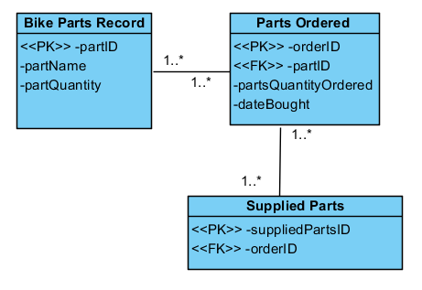

## 3.1.5 Update Rental Record

|  |
| --- |
| **Use Case: Update Rental Record** |
| Owner: Hirings Department |
| **Pre-Conditions** |
| 1. An existing Customer hires an existing bike(s) through the Hirings Department 2. No current reservation on bike(s) 3. Reservation only for primary path |
| **Post-Conditions** |
| 1. Return bike(s) after use |
| **Primary Path** |
| 1. Hirings Department checks Reservation Record 2. Hirings Department finds the bike being hired using bikeID 3. Customer rents out bike 4. Rental Record is updated, time taken out and time due 5. Customer returns bike 6. Rental Record is updated, time due 7. Payment accepted |
| **Alternate Path** |
| 1. Customer asks to rent out a bike in store 2. Hirings Department checks if required bike is available 3. Customer rents out bike 4. Rental Record is updated, time taken out and time due 5. Customer returns bike 6. Rental Record is updated, time due 7. Payment accepted |
|  |
| Faran Azadi |

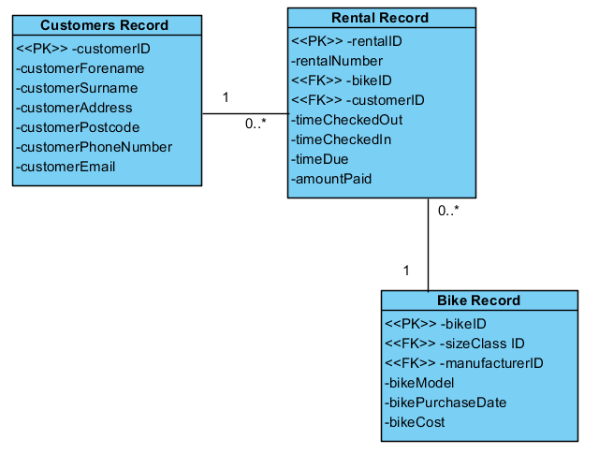

# 4.0 RDAs

## 4.1 Maintenance and Dealer Record RDA

## 4.2 Rental and Bike Record RDA

## 4.3 Merged RDA

# 5.0 ERDs

## 5.1 Top - Down ERD

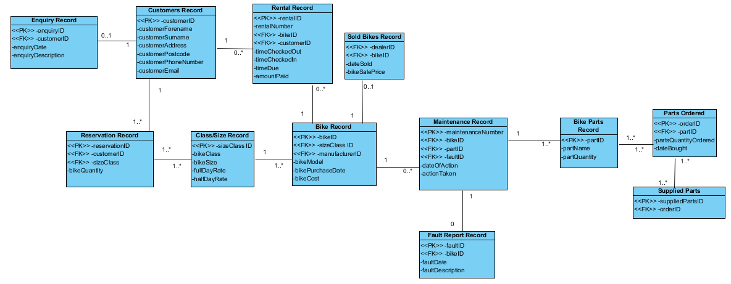

## 5.2 Bottom – Up ERD of Merged RDA

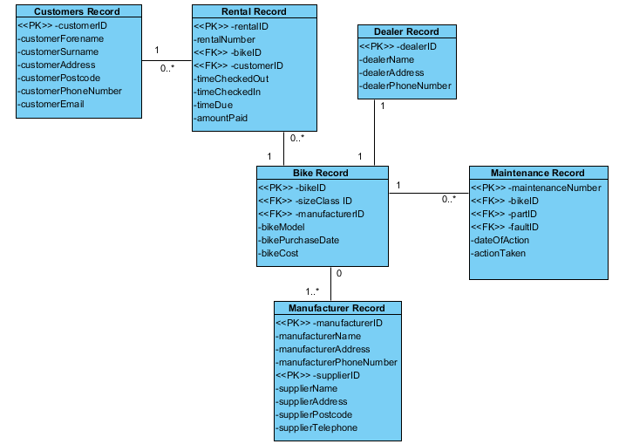

## 5.3 Finalised Group ERD

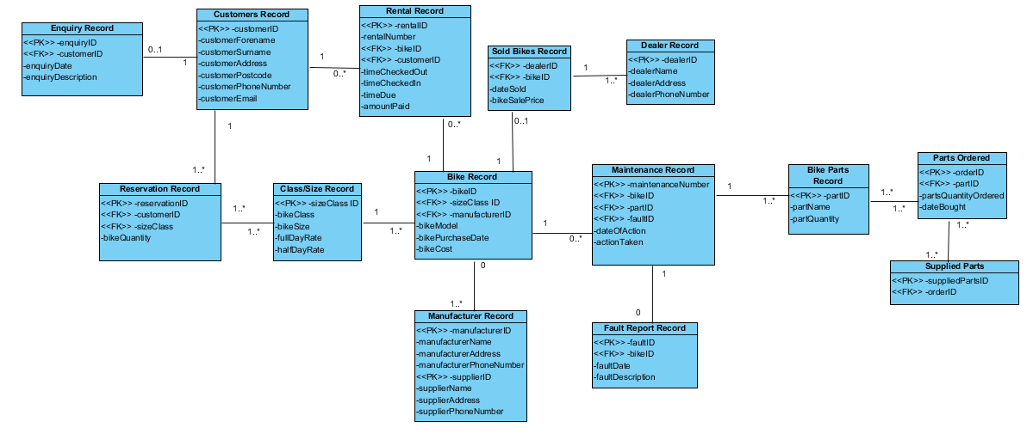

## 5.4 Commentary of ERD Creation

There were many decisions which were made to create our final ERD. For example, for the enquiries record, we assumed that some customers may not enquire about bikes and may just come in and rent the bikes straight from the shop or may just make a reservation without enquiring. For the relationships between the entities, we went through different scenarios which could happen and decided which relationship would make sense. Going through many examples of different ERDs allowed us to get a better understanding of how they work and the relationships between the entities. For many to many relationships, we had to create new weak entities to split the relationships.

# 6.0 Amended Group ERD

# 7.0 Data Dictionaries

## 7.1 Rental Record

|  |  |  |  |  |  |  |
| --- | --- | --- | --- | --- | --- | --- |
| **Attribute Name** | **Key Type** | **FK Table** | **FK Column** | **Data Type** | **Length** | **Constraint** |
| rentalID | PK |  |  | NUMBER | 9 |  |
| bikeID | FK | bikeRecord | bikeID | NUMBER | 9 |  |
| customerID | FK | customersRecord | customerID | NUMBER | 9 |  |
| timeCheckedOut |  |  |  | DATE |  | NOT NULL |
| timeCheckedIn |  |  |  | DATE |  | NOT NULL |
| timeDue |  |  |  | DATE |  | NOT NULL |
| amountPaid |  |  |  | NUMBER | (5,2) |  |

## 7.2 Reservation Record

|  |  |  |  |  |  |  |
| --- | --- | --- | --- | --- | --- | --- |
| **Attribute Name** | **Key Type** | **FK Table** | **FK Column** | **Data Type** | **Length** | **Constraint** |
| reservationID | PK |  |  | NUMBER | 9 |  |
| customerID | FK | customersRecord | customerID | NUMBER | 9 |  |
| classSizeID | FK | classSizeRecord | sizeClassID | NUMBER | 9 |  |
| bikeQuantity |  |  |  | NUMBER | 3 |  |

## 7.3 Dealer Record

|  |  |  |  |  |  |  |
| --- | --- | --- | --- | --- | --- | --- |
| **Attribute Name** | **Key Type** | **FK Table** | **FK Column** | **Data Type** | **Length** | **Constraint** |
| dealerID | PK |  |  | NUMBER | 9 |  |
| dealerName |  |  |  | VARCHAR2 | 30 | NOT NULL |
| dealerAddress |  |  |  | VARCHAR2 | 45 |  |
| dealerPhoneNumber |  |  |  | NUMBER | 13 | NOT NULL, UNIQUE |

## 7.4 Fault Report Record

|  |  |  |  |  |  |  |
| --- | --- | --- | --- | --- | --- | --- |
| **Attribute Name** | **Key Type** | **FK Table** | **FK Column** | **Data Type** | **Length** | **Constraint** |
| faultID | PK |  |  | NUMBER | 9 |  |
| bikeID | FK | bikeRecord | bikeID | NUMBER | 9 |  |
| faultDate |  |  |  | DATE |  |  |
| faultDesc |  |  |  | VARCHAR2 | 140 |  |

## 7.5 Customers Record

|  |  |  |  |  |  |  |
| --- | --- | --- | --- | --- | --- | --- |
| **Attribute Name** | **Key Type** | **FK Table** | **FK Column** | **Data Type** | **Length** | **Constraint** |
| customerID | PK |  |  | NUMBER | 9 |  |
| customerSurname |  |  |  | VARCHAR2 | 30 | NOT NULL |
| customerForename |  |  |  | VARCHAR2 | 30 |  |
| customerAddress |  |  |  | VARCHAR2 | 45 |  |
| customerPostcode |  |  |  | VARCHAR2 | 8 | NOT NULL |
| customerPhoneNumber |  |  |  | NUMBER | 13 | NOT NULL, UNIQUE |
| customerEmail |  |  |  | VARCHAR2 | 45 | UNIQUE |

## 7.6 Enquiry Record

|  |  |  |  |  |  |  |
| --- | --- | --- | --- | --- | --- | --- |
| **Attribute Name** | **Key Type** | **FK Table** | **FK Column** | **Data Type** | **Length** | **Constraint** |
| enquiryID | PK |  |  | NUMBER | 9 |  |
| customerID | FK | customersRecord | customerID | NUMBER | 9 |  |
| enquiryDate |  |  |  | DATE |  |  |
| enquiryDesc |  |  |  | VARCHAR2 | 140 |  |

## 7.7 Sold Bikes Record

|  |  |  |  |  |  |  |
| --- | --- | --- | --- | --- | --- | --- |
| **Attribute Name** | **Key Type** | **FK Table** | **FK Column** | **Data Type** | **Length** | **Constraint** |
| soldBikeID | PK |  |  | NUMBER | 9 |  |
| dealerID | FK | dealerRecord | dealerID | NUMBER | 9 |  |
| bikeID | FK | bikeRecord | bikeID | NUMBER | 9 |  |
| dateSold |  |  |  | DATE |  | NOT NULL |
| bikeSalePrice |  |  |  | NUMBER | (7, 2) |  |

## 7.8 Bike Record

|  |  |  |  |  |  |  |
| --- | --- | --- | --- | --- | --- | --- |
| **Attribute Name** | **Key Type** | **FK Table** | **FK Column** | **Data Type** | **Length** | **Constraint** |
| bikeID | PK |  |  | NUMBER | 9 |  |
| classSizeID | FK | classSizeRecord | classSizeID | NUMBER | 9 |  |
| manufacturerID | FK | manufacturerRecord | manufacturerID | NUMBER | 9 |  |
| bikeModel |  |  |  | VARCHAR2 | 20 |  |
| bikePurchaseDate |  |  |  | DATE |  |  |
| bikeCost |  |  |  | NUMBER | (7,2) |  |

## 7.9 Class / Size Record

|  |  |  |  |  |  |  |
| --- | --- | --- | --- | --- | --- | --- |
| **Attribute Name** | **Key Type** | **FK Table** | **FK Column** | **Data Type** | **Length** | **Constraint** |
| classSizeID | PK |  |  | NUMBER | 9 |  |
| bikeClass |  |  |  | VARCHAR2 | 15 |  |
| bikeSize |  |  |  | VARCHAR2 | 20 |  |
| fullDayRate |  |  |  | NUMBER | (5,2) |  |
| halfDayRate |  |  |  | NUMBER | (5,2) |  |

## 7.10 Maintenance Record

|  |  |  |  |  |  |  |
| --- | --- | --- | --- | --- | --- | --- |
| **Attribute Name** | **Key Type** | **FK Table** | **FK Column** | **Data Type** | **Length** | **Constraint** |
| maintenanceID | PK |  |  | NUMBER | 9 |  |
| bikeID | FK | bikeRecord | bikeID | NUMBER | 9 |  |
| partID | FK | bikePartsRecord | partID | NUMBER | 9 |  |
| faultID | FK | faultReportRecord | faultID | NUMBER | 9 |  |
| dateOfAction |  |  |  | DATE |  |  |
| actionTaken |  |  |  | VARCHAR2 | 140 |  |

## 7.11 Bike Parts Record

|  |  |  |  |  |  |  |
| --- | --- | --- | --- | --- | --- | --- |
| **Attribute Name** | **Key Type** | **FK Table** | **FK Column** | **Data Type** | **Length** | **Constraint** |
| partID | PK |  |  | NUMBER | 9 |  |
| manufacturerID | FK | manufacturerRecord | manufacturerID | NUMBER | 9 |  |
| partName |  |  |  | VARCHAR2 | 30 | NOT NULL |
| partQuantity |  |  |  | NUMBER | 5 | NOT NULL |

## 7.12 Supplied Parts Record

|  |  |  |  |  |  |  |
| --- | --- | --- | --- | --- | --- | --- |
| **Attribute Name** | **Key Type** | **FK Table** | **FK Column** | **Data Type** | **Length** | **Constraint** |
| suppliedPartsID | PK |  |  | NUMBER | 9 |  |
| orderID | FK | orderedPartsRecord | orderID | NUMBER | 9 |  |
| partID | FK | bikePartsRecord | partID | NUMBER | 9 |  |

## 7.13 Ordered Parts Record

|  |  |  |  |  |  |  |
| --- | --- | --- | --- | --- | --- | --- |
| **Attribute Name** | **Key Type** | **FK Table** | **FK Column** | **Data Type** | **Length** | **Constraint** |
| orderID | PK |  |  | NUMBER | 9 |  |
| partID | FK | bikePartsRecord | partID | NUMBER | 9 |  |
| partsQtyOrdered |  |  |  | NUMBER | 30 | NOT NULL |
| dateBought |  |  |  | DATE |  |  |

## 7.14 Manufacturer Record

|  |  |  |  |  |  |  |
| --- | --- | --- | --- | --- | --- | --- |
| **Attribute Name** | **Key Type** | **FK Table** | **FK Column** | **Data Type** | **Length** | **Constraint** |
| manufacturerID | PK |  |  | NUMBER | 9 |  |
| manufacturerName |  |  |  | VARCHAR2 | 45 | NOT NULL |
| manufacturerAddress |  |  |  | VARCHAR2 | 60 | NOT NULL |
| manufacturerPhoneNumber |  |  |  | NUMBER | 13 | NOT NULL |

# 8.0 Reflection on what has been learnt doing SQL

## 8.1 Aamer Atique

This assignment has helped me in learning some very useful skills and since it was a much more of a practical assignment where we had to create a database, my understanding of it has improved immensely. It has proved very useful knowing and understanding what an ERD is to understand the links between each table and how the database will work and communicate with all of its various parts. Creating data dictionaries has also done this as it has helped me understand what the appropriate data type for each attribute should be - I researched the different data types in SQL to help me with this.

Using SQL has helped me learn how, why and where it is used. We used SQL to create queries which were a part of our assignment. Overcoming errors with SQL was challenging, however, was easy to overcome with the help of others. Creating a database in ORACLE was the main part of this assignment and it was interesting how we went from turning our ERD into an actual database which we learnt well through doing it. Overall, I feel I have benefitted from this part of the assignment.

## 8.2 Faran Azadi

In part 3 of this assignment, I encountered some new concepts and also put some things I had learnt from lectures/labs into practice. I found that implementing them into an actual solution benefited me tremendously as I think it is one thing to listen to a teacher talk about something, but to actually do it yourself can only improve your knowledge. As they say, practice makes perfect.

Amending our ERD highlighted the importance of the relationships between the entities in the database to me – one bad relationship can affect everything. Creating the data dictionaries for each table made me realise how simple it is to create the tables once all the thought has already been put into them in regards to the appropriate data types, field lengths, attribute names and field constraints. Another major thing for me in this assignment was gaining experience writing queries. Not only did I practice using functions/operators and make use of an inner join, but I had a lot more time to get used to SQL Developer and APEX.

## 8.3 Naim Ahmed

During this part of the assignment, there are many skills which I have managed to obtain in this short span of time. I’ve learnt how to create data dictionaries for each of the tables that will be created for the database and seen how useful they are when it comes to creating the database. I’ve expanded my knowledge of the different data types which are available to be used in databases and why different data types are used for different values such as dates and strings.

I’ve also learned how to use data manipulating software that is used in the information technology industry which businesses use, such as, Oracle SQL Developer and APEX, an online application which can be used to make databases. Learning the process of how to create queries to gather the data which you need has allowed me to understand why these programs, such as, SQL Developer are so important to businesses who have large amounts of data, as using queries allows you to obtain the data you need to make business decisions.

## 8.4 Yusof Bandar

Finishing and amending our final ERD solidified my understanding of ERDs, fully understanding the way the relationships and weak entities work. Furthermore, using the data dictionary gave me a firm understanding of different data types, such as, VARCHAR2 and NUMBER() to format the data, also learning what types of constraints there are and how they operate.

Creating tables, inserting and selecting data using SQL Developer and APEX gave me understanding on how SQL works. Firstly, simply learning the syntax for SQL and avoiding common errors furthered my understanding. Additionally, using complex data types such as DATE and TIMESTAMP helped me to recognise how SQL stores data and how to avoid string errors. Overall, I learnt how SQL scripts and queries work, also learning how to write data dictionaries.

## 8.5 Pritam Sangani

Creating data dictionaries has helped me learn about the different data types in SQL, such as, NUMBER, DATE and VARCHAR2. I was also able to determine which data type was best to use for each attribute. I was able to understand the importance of creating data dictionaries before implementing the database in ORACLE as it helped to think about what constraints and relationships there were between entities before creating the tables.

While implementing the database in ORACLE SQL Developer and APEX, I learnt about the syntax in SQL, such as, CREATE, DROP, INSERT INTO and SELECT. I learnt how to create tables, insert data in the tables and how to run queries using the syntax that I had learnt.

# 9.0 Conclusion

## 9.1 Aamer Atique

## 9.2 Faran Azadi

## 9.3 Naim Ahmed

## 9.4 Yusof Bandar

## 9.5 Pritam Sangani

# 10.0 Appendices

## 10.1 References

Chewning, C. (2013, July 21). *Exception Reporting- Improving Key Business Drivers*. Retrieved from Accounting Library: www.accountinglibrary.com/blog/exception-reporting-2/

Whiteley, D. (2013). *An Introduction to Information Systems.* Palgrave Macmillan.

## 10.2 Appendix A: Log Book

## 10.3 Appendix B: Presentation Slides